User Acceptance Testing (UAT) Template
Automated Network Request Management
Date
Project Name | Automated Network Request Management in ServiceNow
Team ID
Maximum Marks | 4 Marks

Project Overview
Project Name: Automated Network Request Management in ServiceNow
Project Description: Automating network request management in ServiceNow enhances operational efficiency by streamlining workflows, reducing manual interventions, and ensuring real-time updates. The project implements a fully automated and scalable network change management process to handle user-initiated network requests, ensuring rapid fulfillment, audit-ready change records, and accurate configuration tracking.
Project Version: 1.0
Testing Period: [Start Date] to [End Date]

Testing Scope
- Network request submission through the Service Catalog
- Automated approval workflow (Flow Designer) based on request type and priority
- Auto-generation of audit-ready Change Records
- CMDB configuration item creation and updates
- Real-time status notifications to requestors and approvers
- Role-based access control across requestor, approver, and network admin roles
- Integration with network orchestration layer via REST APIs

Testing Environment
URL / Location: [ServiceNow test instance URL]
Credentials (if required): [Username / Password – shared securely, not in this document]
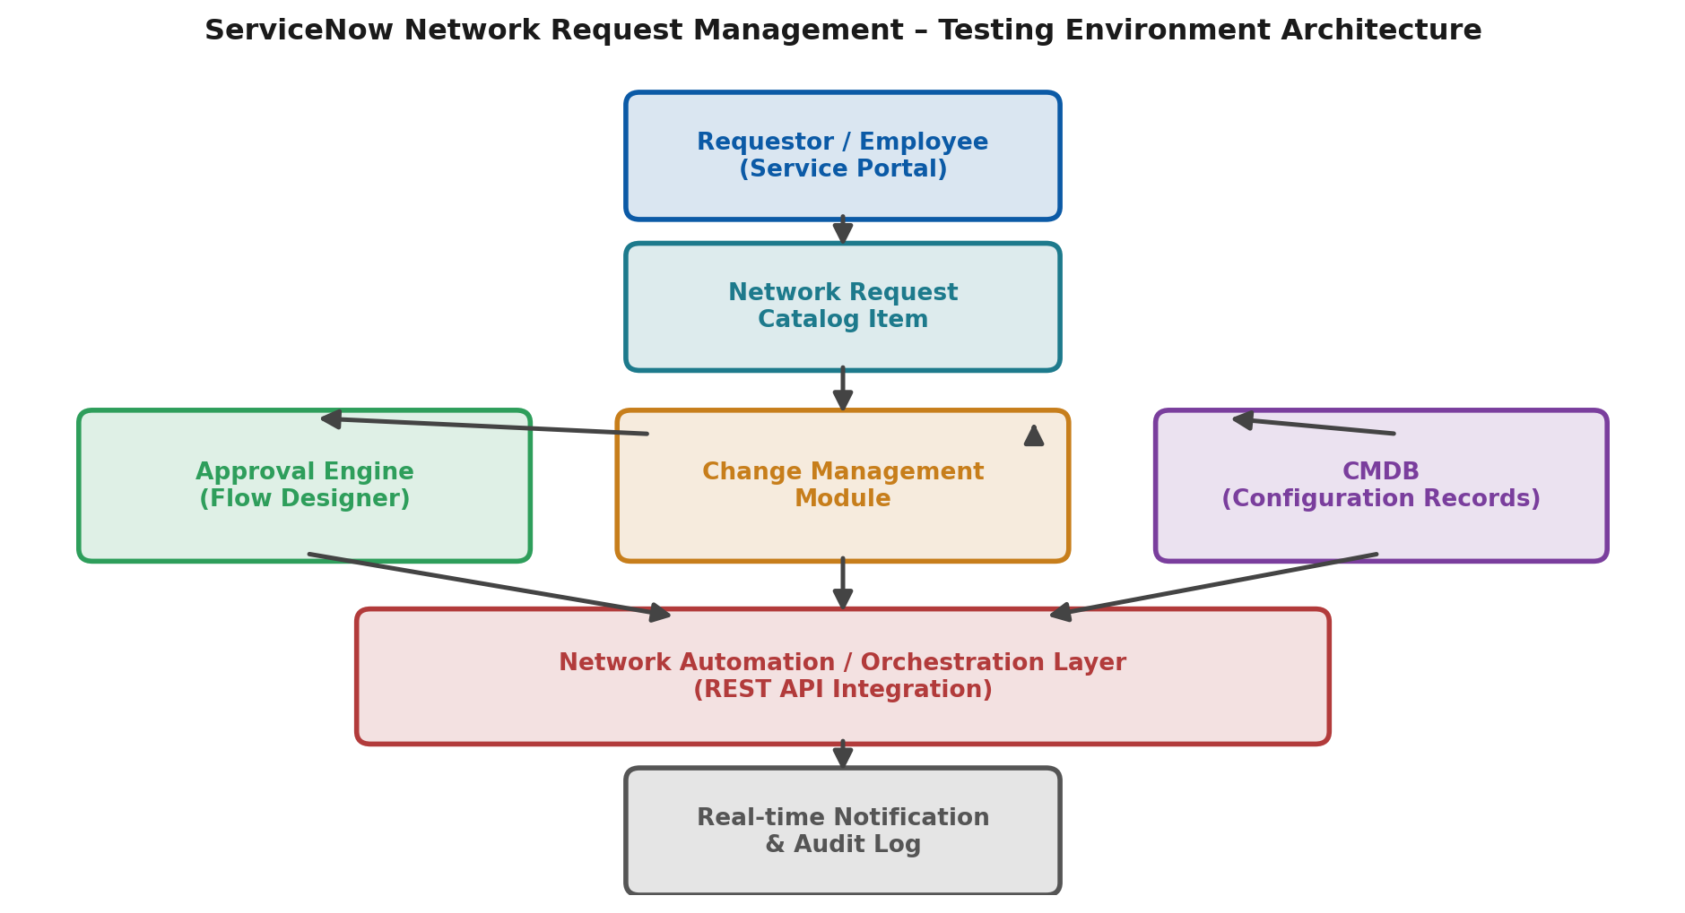
Figure 1: Testing environment architecture for the ServiceNow network request module

Test Cases
Test Case ID | Test Scenario | Test Steps | Expected Result | Actual Result | Pass/Fail
TC-001 | Requestor submits a new network request via Service Catalog | 1. Log in to Service Portal2. Open 'Network Request' catalog item3. Fill required details and submit | Request is created with unique number and routed to approval
TC-002 | Approver reviews and approves a network request | 1. Log in as Approver2. Open pending approval3. Approve with comments | Request status updates to Approved; Change Record is generated
TC-003 | Network Change Record links correctly to CMDB CI | 1. Open approved request2. Verify linked Change Record3. Check CMDB CI relationship | Change Record and CMDB CI are accurately linked and updated
TC-004 | Requestor receives real-time status notifications | 1. Track request from submission to closure2. Monitor email/portal alerts | Notifications are received at every state transition
TC-005 | Audit trail is complete and exportable | 1. Open a closed request2. Review activity/audit log3. Export log | Audit trail shows all actions with timestamps and is exportable
TC-006 | Unauthorized user cannot approve requests | 1. Log in with requestor role2. Attempt to access approval action | System denies access; role-based restriction enforced

Bug Tracking
Bug ID | Bug Description | Steps to Reproduce | Severity | Status | Additional Feedback
BG-001 | [Describe the issue or bug encountered] | 1. [Step 1]2. [Step 2]3. [Step 3] | [Low/Medium/High] | [Open/In Progress/Closed] | [Any additional comments]
... | ... | ... | ... | ... | ...

Sign-off
Tester Name: [Name of Tester]
Date: [Date of Test Completion]
Signature: [Tester's Signature]

Notes
- Ensure that all test cases cover both positive and negative scenarios.
- Encourage testers to provide detailed feedback, including suggestions for improvement.
- Bug tracking should include severity, status, and clear steps to reproduce.
- Obtain sign-off from both the project manager and product owner before proceeding with deployment.

